Connect to aws academy

set the aws credentials in cli (with session tooken)

Create s3 with public policy and puclic access

Create an ec2 instance ( amazon Linux )

Create new key pair (Rsa , ppk for windows, pem for mac)

go to security groups in console  
  
add inbound rules

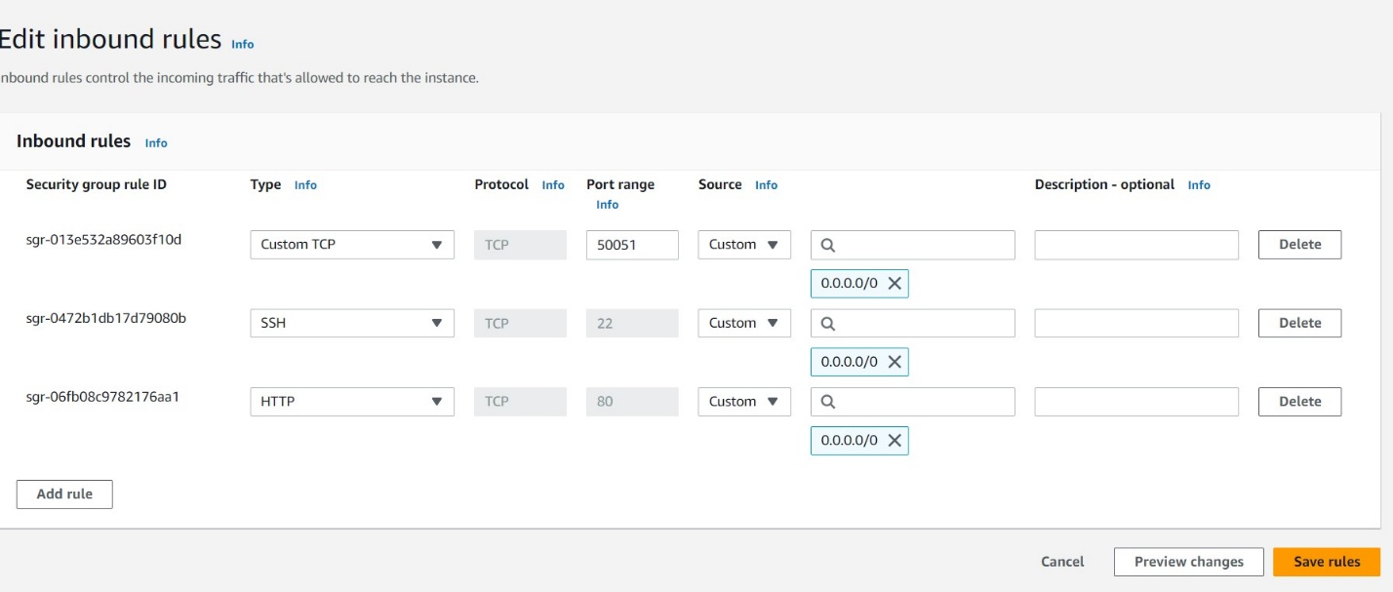

Now add you security group to ur instance  
  
Launch instance

Connect to the instance

Install all dpendecies like python grpc and other imported dependencies

sudo yum update  
 sudo yum install python3

sudo yum install python3-pip

pip3 install grpcio grpcio-tools

pip3 install boto3

select the instance

actions -> security-> modify I am

choose Labinstance

update

Now use winscp softaware to add files into the ec2 instance

Youube: https://www.youtube.com/watch?v=nSX4GjnmGlU

Add pb2.py and pb2 grpc.py

Add sever file (server.py file)

Now go back to ece connection

Run the server file (python3 server.py)

Go to Postman, hit the link given by prof

<http://54.173.209.76:9000/start>

copy you public ipv4 address of you ec2

add post request with json with banner id and ip

hit it